

Name = Rudra Gupta

Sap Id = 590011955

Batch = 38

Submitted To = Mr. Manish Giri

PYTHON PROJECT REPORT
FUN CITY

📌 Overview:
FUN CITY is a terminal-based Python application that brings together a collection of mini-games, utilities, and ordering systems in one interactive menu. The user can play games, order food, calculate shared expenses, take a quiz, check love/friendship compatibility, and even visualize data with a simple graph.

Code:

import sys

import time

import random

import numpy as np

import pandas as pd

import matplotlib.pyplot as plt

# tictactoe

def print_board(board):

i=0

for row in board:

print(" | ".join(row))

if i< len(board)-1:

print("---------")

i+=1

print()

def make_move(board, row, col, symbol):

if board[row][col] == " ":

board[row][col] = symbol

return True

return False

def check_win(board, symbol):

board_array=np.array(board)

for i in range(3):

if np.all(board_array[i] == symbol) or np.all(board_array[:, i] == symbol):

return True

if np.all(np.diag(board_array) == symbol) or np.all(np.diag(np.fliplr(board_array)) == symbol):

return True

return False

def check_draw(board):

return all([cell != " " for row in board for cell in row])

#rockpaper

def determine_winner(player_choice, computer_choice):

if player_choice == computer_choice:

return "tie"

elif (player_choice == "rock" and computer_choice == "scissors") or \

(player_choice == "paper" and computer_choice == "rock") or \

(player_choice == "scissors" and computer_choice == "paper"):

return "player"

else:

return "computer"

# NumberGuezz

class NumberGuezz:

def __init__(self, lower_bound, upper_bound, max_attempts):

self.lower_bound = lower_bound

self.upper_bound = upper_bound

self.max_attempts = max_attempts

self.secret_number = random.randint(lower_bound, upper_bound)

self.attempts = 0

def get_guess(self):

while True:

try:

guess = int(input(f"Guess a number between {self.lower_bound} and {self.upper_bound}: "))

if self.lower_bound <= guess <= self.upper_bound:

return guess

else:

print("Invalid input. Please enter a number within the specified range.")

except ValueError:

print("Invalid input. Please enter a valid number.")

def play(self):

print("Welcome to the Number Guessing Game!")

while self.attempts < self.max_attempts:

guess = self.get_guess()

self.attempts += 1

if guess == self.secret_number:

print(f"Congratulations! You guessed the secret number {self.secret_number} in {self.attempts} attempts.")

return

elif guess < self.secret_number:

print("Nahh")

else:

print("Nahh")

print(f"Sorry, you ran out of attempts! The secret number was {self.secret_number}.")

# Advanced Number Guezz

class AdvancedNumberGuessGame(NumberGuezz):

def __init__(self, lower_bound, upper_bound, max_attempts):

super().__init__(lower_bound, upper_bound, max_attempts)

self.hints_enabled = True

def play(self):

print("Welcome to the Advanced Number Guessing Game!")

while self.attempts < self.max_attempts:

guess = self.get_guess()

self.attempts += 1

if guess == self.secret_number:

print(f"Congratulations! You guessed the secret number {self.secret_number} in {self.attempts} attempts.")

return

elif guess < self.secret_number:

print("Too low!")

if self.hints_enabled:

print(f"The secret number is greater than {guess}.")

else:

print("Too high!")

if self.hints_enabled:

print(f"The secret number is less than {guess}.")

print(f"Sorry, you ran out of attempts! The secret number was {self.secret_number}.")

#Splitwise

def members(no):

i = 1

while no > 0:

name = input(f"Enter Name {i}: ").upper()

friends[name] = 0

i += 1

no -= 1

def expense(total,no):

while True:

try:

amount = int(input("Enter amount spent: "))

name = input("Who spent it? ").upper()

friends[name] = friends.get(name, 0) + amount

total += amount

choice = input("Do you want to add another expense?(Y/N) ").upper()

if choice == "N":

break

elif choice != "Y":

print("Invalid Choice.")

except ValueError:

print("Invalid input. Please enter a number for the amount.")

print(friends)

print(f"Total expense of group is {total}.")

owe(total, no)

return total

def owe(total,no):

each=total/no

for i in friends:

if friends[i]>each:

print(f"{i} is owed {friends[i]-each} {currency}.")

elif friends[i]<each:

print(f"{i} is owes {each-friends[i]} {currency}.")

else:

print(f"{i} does not owe anything.")

#Quiz

def choose():

quizes = ["Anime Quiz", "Python Quiz"]

for index, option in enumerate(quizes, start=1):

print(f"{index}: {option}")

choice = int(input("Enter the number corresponding to your choice: "))

if choice in [1, 2]:

quiz(choice)

else:

print("Invalid choice! Please select a valid option.")

choose()

def quiz(choice):

right=0

wrong=0

if choice==1:

questions = [

("What does 'Kaizoku ou ni ore wa naru' mean in English?",

["A- I will be Hokage!",

"B- I will become the Pokemon Master!",

"C- I will be the King of Pirate!",

"D- I am a Saiyan from Earth."],

"C"),

("Who is Pain's Sensei?",

["A- Jiraya Sensei",

"B- King Kai",

"C- Koro Sensei",

"D- Kakashi Sensei"],

"A"),

("Who is Natsu's father?",

["A- Acnologia",

"B- Igneel",

"C- Aldoron",

"D- Ignia"],

"B"),

("Who is the villain in Demon Slayer?",

["A- Muzan Kibutsuji",

"B- Tanjiro Kamado",

"C- Michael Jackson",

"D- Goku"],

"A"),

("Who is Ash's Pokemon?",

["A- Pikachu",

"B- Charmander",

"C- Squirtle",

"D- Lugia"],

"A")

]

for question, options, correct_answer in questions:

print(question)

for option in options:

print(option)

ans = input("Enter your choice: ").upper()

if ans == correct_answer:

time.sleep(1)

print("Right Answer!")

right += 1

else:

time.sleep(1)

print("Sorry! Wrong Answer")

wrong += 1

time.sleep(2)

print(f"\nQuiz Finished! You got {right} right answers and {wrong} wrong answers.")

elif choice==2:

questions = [

("What is the output of print(2 ** 3)?",

["A- 6",

"B- 8",

"C- 9",

"D- 3"],

"B"),

("Which of the following is a mutable data type?",

["A- Tuple",

"B- String",

"C- List",

"D- Dictionary"],

"C"),

("What keyword is used to define a function in Python?",

["A- func",

"B- define",

"C- def",

"D- function"],

"C"),

("What will be the output of 'Hello, World!'[7]?",

["A- H",

"B- W",

"C- o",

"D- ,"],

"D"),

("Which of the following is not a valid variable name in Python?",

["A- my_var",

"B- _myVar",

"C- myVar1",

"D- 1myVar"],

"D")

]

for question, options, correct_answer in questions:

print(question)

for option in options:

print(option)

ans = input("Enter your choice: ").upper()

if ans == correct_answer:

time.sleep(1)

print("Right Answer!")

right += 1

else:

time.sleep(1)

print("Sorry! Wrong Answer")

wrong += 1

time.sleep(2)

print(f"\nQuiz Finished! You got {right} right answers and {wrong} wrong answers.")

#Main

print("\t\t\t\tFUN CITY")

print("""------------------------------------------------------------------------""")

print("Main Menu")

print("What do you want to do?")

a=("Play a Game","Order Food","Use Splitwise","Use Love/Friendship Meter","Play a Quiz","Make a Graph")

for index, option in enumerate(a, start=1):

print(f"{index}: {option}")

choice=int(input("Enter the number corresponding to your choice:"))

if choice==1:

print("Welcome to Gamezone")

print("Which Game do you want to play?")

game=("Tic-Tac-Toe","Rock-Paper-Scissors","Number Guezz")

for index, option in enumerate(game, start=1):

print(f"{index}: {option}")

choice=int(input("Enter the number corresponding to your choice:"))

if choice==1:

board = [[" " for _ in range(3)] for _ in range(3)]

player1_symbol = "X"

player2_symbol = "O"

current_player = player1_symbol

while True:

try:

print_board(board)

row = int(input(f"Player {current_player}, enter row (1-3): "))

col = int(input(f"Player {current_player}, enter column (1-3): "))

row-=1

col-=1

if make_move(board, row, col, current_player):

if check_win(board, current_player):

print_board(board)

print(f"Player {current_player} wins!")

break

elif check_draw(board):

print_board(board)

print("It's a draw!")

break

current_player = player2_symbol if current_player == player1_symbol else player1_symbol

else:

print("Invalid move, try again.")

except ValueError:

print("Invalid Input.Please enter 1, 2 or 3.")

except IndexError:

print("Invalid Input.Please enter 1, 2 or 3.")

elif choice==2:

choices = ["rock", "paper", "scissors"]

scores = {"player": 0, "computer": 0, "tie": 0}

print("Rock Paper Scissors Game!")

print("Enter 'quit' to exit the game")

while True:

player_input = input("\nChoose rock, paper, or scissors: ").lower()

if player_input == "quit":

break

if player_input not in choices:

print("Invalid choice. Please try again.")

continue

computer_choice = random.choice(choices)

print(f"\nYou chose: {player_input}")

print(f"Computer chose: {computer_choice}")

result = determine_winner(player_input, computer_choice)

if result == "tie":

print("It's a tie!")

else:

print(f"{result.capitalize()} wins this round!")

scores[result] += 1

print(f"\nCurrent scores:")

print(f"Player: {scores['player']} Computer: {scores['computer']} Ties: {scores['tie']}")

print("\nFinal Scores:")

print(f"Player: {scores['player']} Computer: {scores['computer']} Ties: {scores['tie']}")

print("Thanks for playing!")

elif choice==3:

choice=input("Would you like Normal or Hard Mode(N/H):").upper()

if choice=='N':

basic_game = NumberGuezz(1,100,10)

basic_game.play()

elif choice=='Y':

advanced_game = AdvancedNumberGuessGame(1, 100, 10)

advanced_game.play()

elif choice==2:#Order

food=("Order Burger","Order Pizza","Order Fries","Order Drink")

for index, option in enumerate(food, start=1):

print(f"{index}: {option}")

choice=int(input("Enter the number corresponding to your choice:"))

if choice==1:#Burger

print("Welcome to Burgers Inn")

no=int(input("Enter the number of burgers you would like to order:"))

s=0

while no>0:

print("Which burger would you like to have?")

burgers=("Aloo Tikki","Veggie","Paneer","Egg","Chicken","Double Cheese")

for index, option in enumerate(burgers, start=1):

print(f"{index}: {option}")

choice=int(input("Enter the number corresponding to your choice:"))

if choice==1:

s+=50

print("Aloo Tikki costs 50 rupees.")

elif choice==2:

s+=70

print("Veggie costs 70 rupees.")

elif choice==3:

s+=90

print("Veggie costs 90 rupees.")

elif choice==4:

s+=70

print("Egg costs 70 rupees.")

elif choice==5:

s+=120

print("Chicken costs 120 rupees.")

elif choice==6:

s+=70

print("Double Cheese costs 70 rupees.")

else:

print("Invalid Choice")

sys.exit(0)

no-=1

print(f"Your total is {s} rupees.\nYou will receive your order in less than 15 minutes.")

elif choice==2:#Pizza

print("Welcome to Pizza's Mania")

s=0

size=("4 Slices","6 Slices","8 Slices")

for index, option in enumerate(size, start=1):

print(f"{index}: {option}")

choice=int(input("Enter the number corresponding to your choice:"))

if choice==1:

s+=100

elif choice==2:

s+=150

elif choice==3:

s+=180

else:

print("Invalid Choice.")

sys.exit(0)

p=input("Would you like to add Corn(Y/N):").upper()

if p=="Y":

s+=30

elif p=="N":

print("\t")

else:

print ("Invalid Choice.")

sys.exit(0)

p=input("Would you like to add Paneer(Y/N):").upper()

if p=="Y":

s+=50

elif p=="N":

print("\t")

else:

print ("Invalid Choice.")

sys.exit(0)

p=input("Would you like to add Chicken(Y/N):").upper()

if p=="Y":

s+=80

elif p=="N":

print("\t")

else:

print ("Invalid Choice.")

sys.exit(0)

p=input("Would you like to add Onion(Y/N):").upper()

if p=="Y":

s+=30

elif p=="N":

print("\t")

else:

print ("Invalid Choice.")

sys.exit(0)

p=input("Would you like to add Capsicum(Y/N):").upper()

if p=="Y":

s+=20

elif p=="N":

print("\t")

else:

print ("Invalid Choice.")

sys.exit(0)

p=input("Would you like to add Olives(Y/N):").upper()

if p=="Y":

s+=40

elif p=="N":

print("\t")

else:

print ("Invalid Choice.")

sys.exit(0)

p=input("Would you like to add Cheese Burst(Y/N):").upper()

if p=="Y":

s+=80

elif p=="N":

print("\t")

else:

print ("Invalid Choice.")

sys.exit(0)

print(f"Your total is {s} rupees.\nYou will receive your order in less than 30 minutes.")

elif choice==3:#Fries

print("Welcome to Fried Fries")

fries=("Salted","Cheesy","Peri-Peri","Zig-Zag")

s=0

for index, option in enumerate(fries, start=1):

print(f"{index}: {option}")

choice=int(input("Enter the number corresponding to your choice:"))

if choice==1:

s+=50

elif choice==2:

s+=100

elif choice==3:

s+=80

elif choice==4:

s+=70

else:

print("Invalid Choice.")

sys.exit(0)

print(f"Your total is {s} rupees.\nYou will receive your order in less than 15 minutes.")

elif choice==4:#Drinks

print("Welcome to Drinks")

drinks=("Coke","Lassi","Pepsi","Fanta","Orange Juice","Mango Juice","Chocolate Shake","Oreo Shake","Kit Kat Shake","Strawberry Shake","Mango Shake","Baadaam Milk")

s=0

no=int(input("Enter number of drinks you would like to order:"))

while no>0:

for index, option in enumerate(drinks, start=1):

print(f"{index}: {option}")

choice=int(input("Enter the number corresponding to your choice:"))

if choice==1:

s+=50

elif choice==2:

s+=80

elif choice==3:

s+=50

elif choice==4:

s+=50

elif choice==5:

s+=70

elif choice==6:

s+=70

elif choice==7:

s+=100

elif choice==8:

s+=100

elif choice==9:

s+=100

elif choice==10:

s+=90

elif choice==11:

s+=90

elif choice==12:

s+=90

else:

print("Invalid Choice.")

sys.exit(0)

no-=1

print(f"Your total is {s} rupees.\nYou will receive your order in less than 10 minutes.")

else:

print("Invalid Choice.")

sys.exit(0)

elif choice==3:#Splitwise

print("Handle Group Spending With Ease\n\t\tSplitwise")

no=int(input("How many members are there in the group?"))

friends={}

total=0

currency=input("Enter Currency:")

members(no)

expense(total,no)

elif choice==4:#Meter

choice=input("Would you like use love or friendship meter?(L/F)").upper()

m=0

if choice=="L":

n1=input("Enter Name 1:").upper()

n2=input("Enter Name 2:").upper()

for i in n1:

if i=="L" or i=="O" or i=="V" or i=="E":

m+=1

for i in n2:

if i=="L" or i=="O" or i=="V" or i=="E":

m+=1

if m>10:

m=m/10+m%10

if m>=0 and m<=3:

print (f"Your score is {m}.")

print("You will face problems.But dont give up!\nKeep Going!")

elif m>3 and m<=6:

print (f"Your score is {m}.")

print("Congrats! You are made for each other!")

elif m>6 and m<=9:

print (f"Your score is {m}.")

print("You will face problems.But dont give up!\nKeep Going!")

elif choice=="F":

n1=input("Enter Name 1:").upper()

n2=input("Enter Name 2:").upper()

for i in n1:

if i=="F" or i=="R" or i=="I" or i=="E" or i=="N" or i=="D":

m+=1

for i in n2:

if i=="F" or i=="R" or i=="I" or i=="E" or i=="N" or i=="D":

m+=1

if m>10:

m=m/10+m%10

if m>=1 and m<=3:

print (f"Your score is {m}.")

print("You will have some different opinions but you can make it work.")

elif m>3 and m<=6:

print (f"Your score is {m}.")

print("Congrats! You are like siblings!")

elif m>6 and m<=9:

print (f"Your score is {m}.")

print("You will have some different opinions but you can make it work.")

else:

print("Invalid choice")

sys.exit(0)

elif choice==5:#Quiz

choose()

elif choice==6:

data = {

"Game": ["Tic-Tac-Toe", "Rock-Paper-Scissors", "Number Guess"],

"Score": [random.randint(1, 100), random.randint(1, 100), random.randint(1, 100)]

}

df = pd.DataFrame(data)

plt.figure(figsize=(8, 6))

plt.bar(df["Game"], df["Score"], color="skyblue")

plt.xlabel("Game")

plt.ylabel("Score")

plt.title("Game Scores")

plt.show()

else:

print("Invalid Choice.")

🧭 Main Menu:
Upon launching, the user is presented with a main menu offering six core functionalities:
- Play a Game
- Order Food
- Use Splitwise
- Use Love/Friendship Meter
- Play a Quiz
- Make a Graph

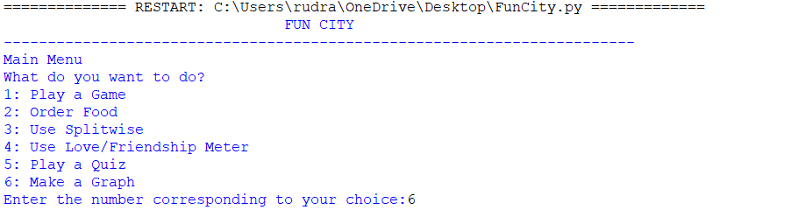

🎲 1. Game Zone

Supported Games:
- Tic-Tac-Toe
  - 2-player game on a 3x3 grid
  - Tracks moves and checks for win/draw using NumPy arrays

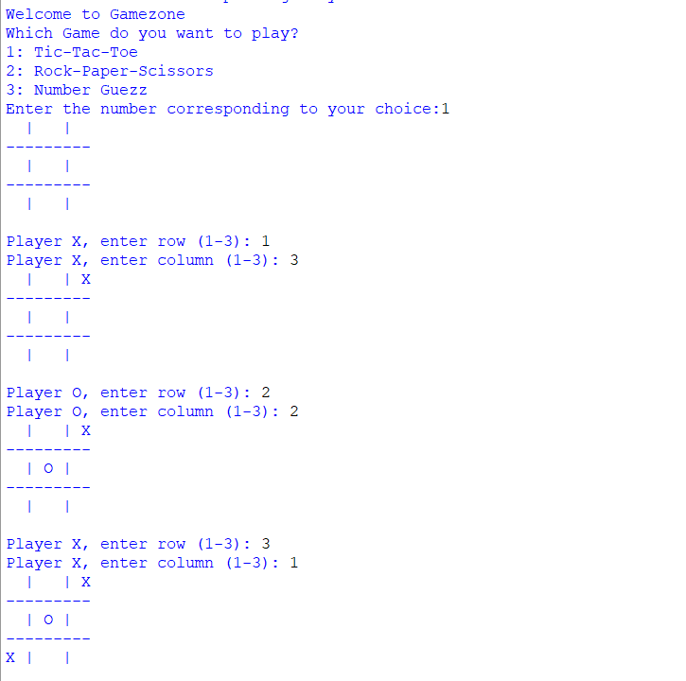
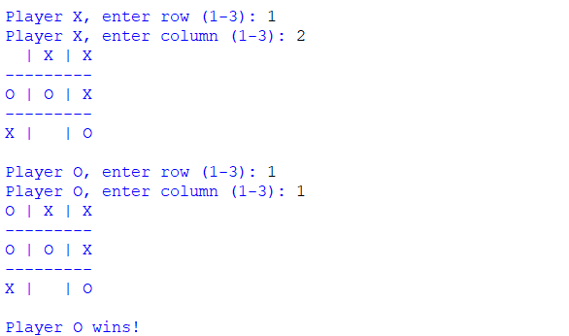

- Rock-Paper-Scissors
  - Player vs Computer
  - Tracks scores until player types 'quit'
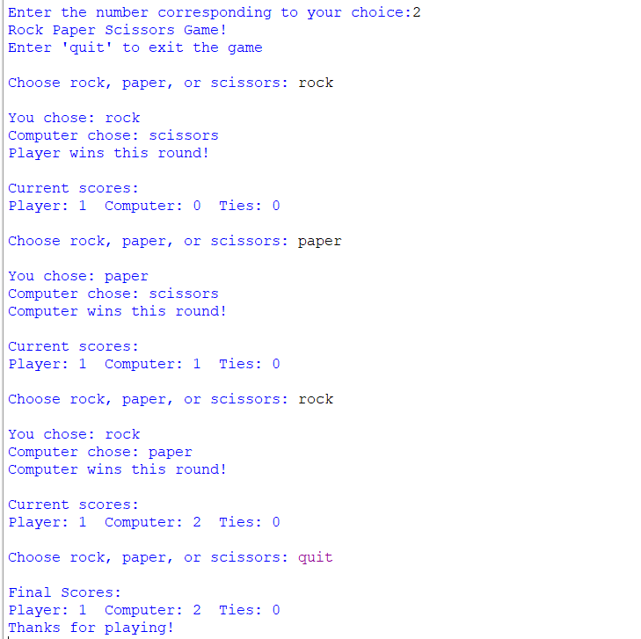

- Number Guezz
  - Normal Mode: Basic guessing game
  - Hard Mode: Advanced version with hints
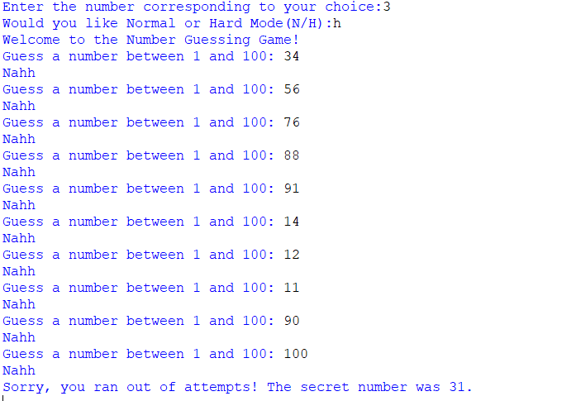

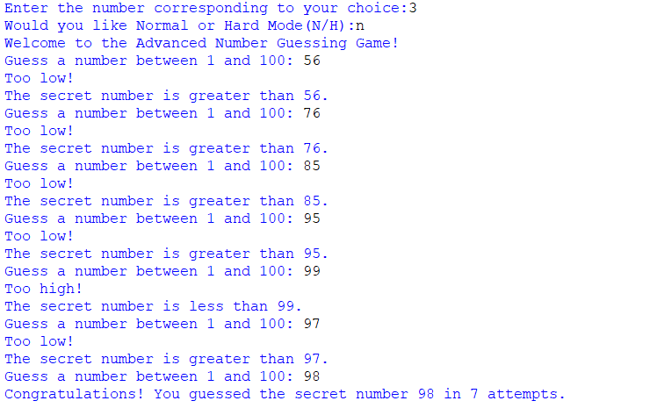
🍔 2. Food Ordering System
A virtual food ordering simulation broken down into four categories:
- Burgers – Multiple types with pricing
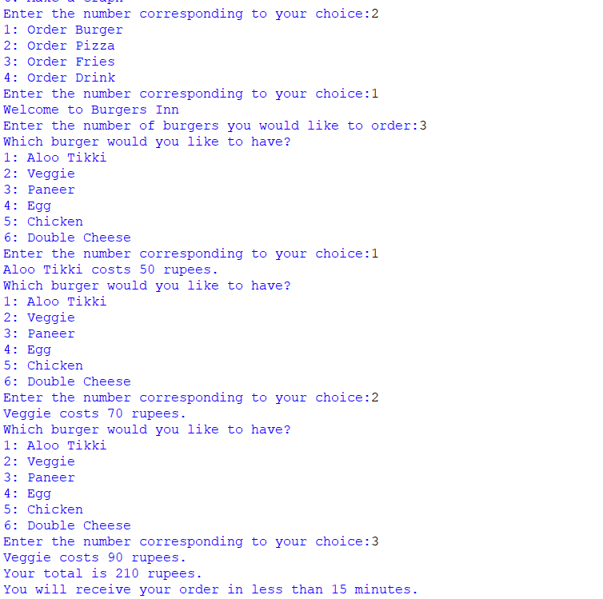
- Pizza – Customizable with toppings
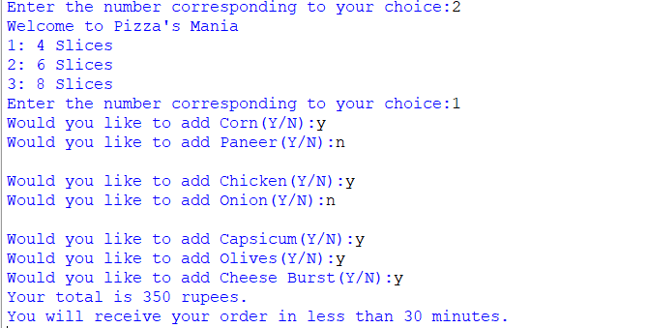

- Fries – Multiple flavors
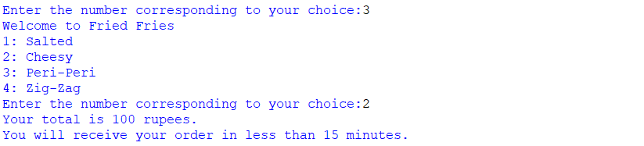
- Drinks – Wide selection of beverages
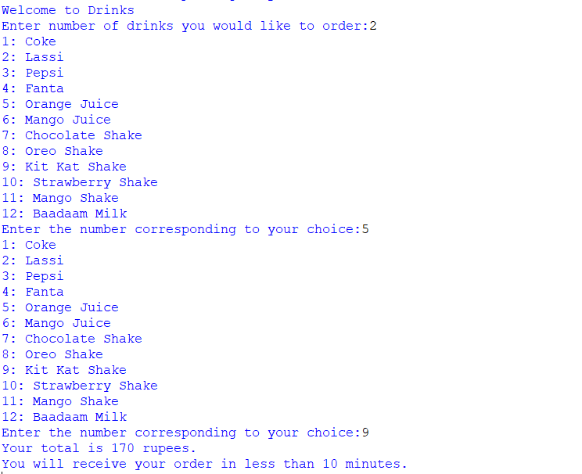

Features:
- Cost calculation per selection
- User prompted through nested menus
- Estimated delivery time shown after order

💸 3. Splitwise Feature
A simplified version of Splitwise to split group expenses:
- Takes number of members and their names
- Records expenses contributed by each member
- Calculates the average cost per person
- Outputs how much each person owes or is owed
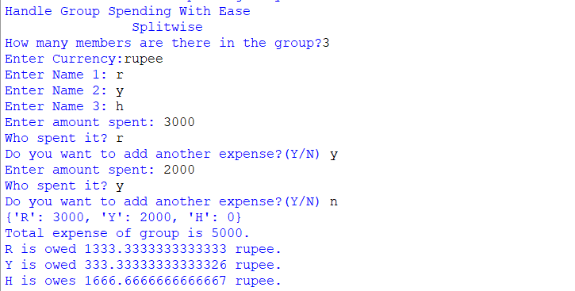

❤️ 4. Love/Friendship Meter
A fun utility that provides a "compatibility score" between two names:
- Love Meter: Counts occurrences of "L, O, V, E"
- Friendship Meter: Counts occurrences of "F, R, I, E, N, D"
- Based on the score, it gives motivational or congratulatory messages
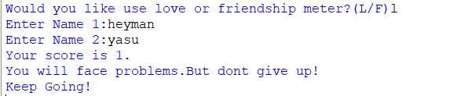

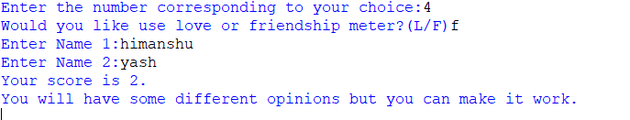

🧠 5. Quiz Game
Two categories of quizzes:
- Anime Quiz
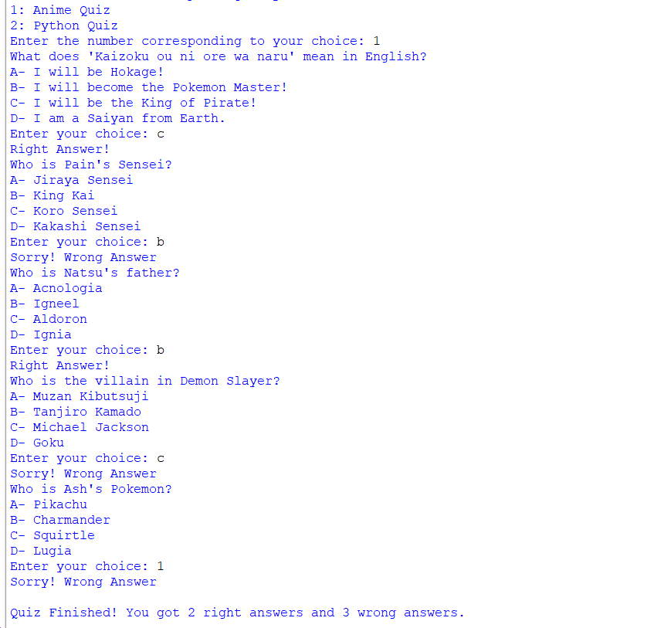
- Python Programming Quiz
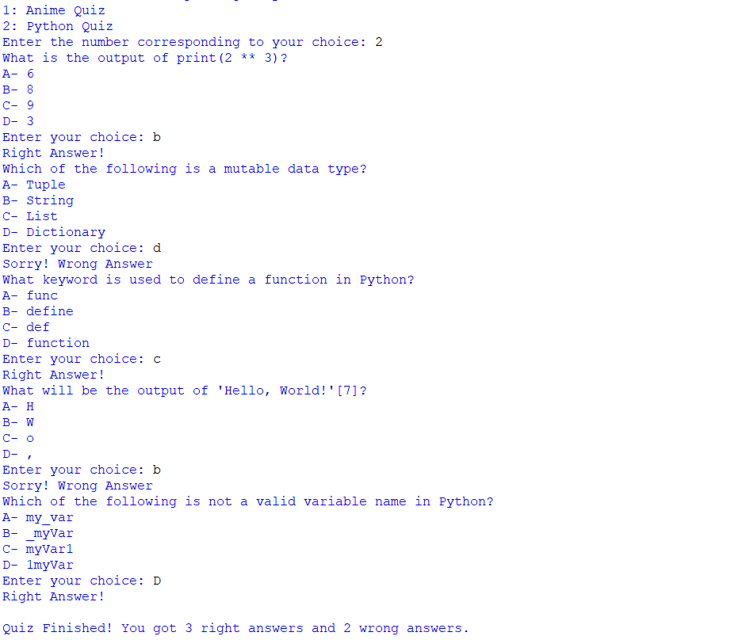

Features:
- Multiple-choice questions (5 each)
- Tracks correct and incorrect answers
- Delivers final score at the end

📊 6. Graph Visualization
Generates a random score for the three games:
- Tic-Tac-Toe
- Rock-Paper-Scissors
- Number Guess

Visualized Using:
- Matplotlib bar chart
- Shows performance comparison across games
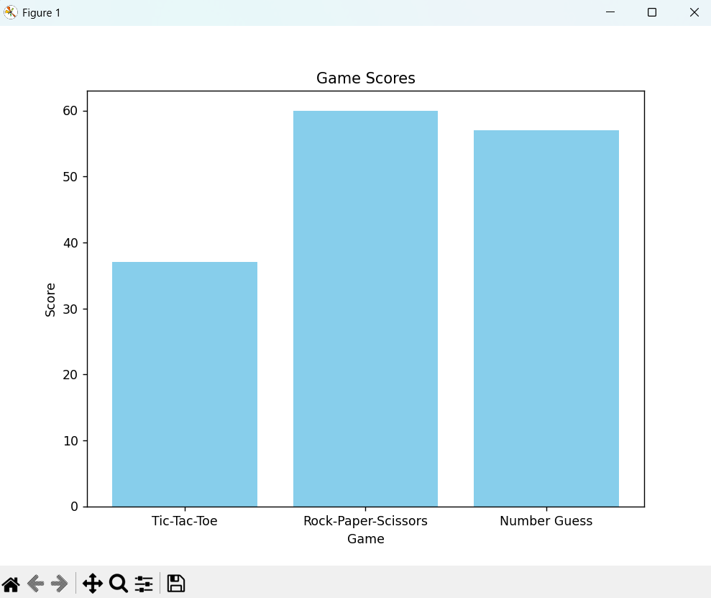

🛠️ Modules & Libraries Used:
- numpy: For matrix operations in Tic-Tac-Toe
- pandas: For data handling in visualization
- matplotlib.pyplot: For graph plotting
- random: For randomness in games
- sys: For early exit in case of errors
- time: For adding delays to improve UI experience

